System Access Management

Use Case Specifications

Contents

Actors 3
Executive 4
IT 5
Supervisor 6
Use Case Diagrams 7
Authy Use Case Diagrams 8
Use Cases 10
Create New Request 11
View Requests 15
Manage Requests 17
Manage Authorizations 18
Manage Authorization Group 19
Manage Employees 20
Manage Employee Group 21
Manage users 22
Manage Roles 23
View Reports 24

Actors

Executive
ACTR-103

Description
Executive is primarily responsible for managing (approve or decline) requests at first step

Goals
view requests
manage requests

Use Cases where this actor is a Primary Actor
View Requests | UC-106
Manage Requests | UC-107

Use Cases where this actor is a Supporting Actor
Create New Request | UC-105

Updated By: Lewis Update Date: 3/31/2016

IT
ACTR-102

Description
IT is primarily responsible for managing all requests with terminal decision.
Also, IT has the highest privilege in the system so that they can manage roles, users, employees, etc..

Goals
view requests
manage requests
manage authorizations
manage authorization group
manage employees
manage employee group
manage users
manage roles
view reports

Use Cases where this actor is a Primary Actor
View Requests | UC-106
Manage Requests | UC-107
Manage Authorizations | UC-108
Manage Authorization Group | UC-109
Manage Employees | UC-110
Manage Employee Group | UC-111
Manage users | UC-112
Manage Roles | UC-113
View Reports | UC-114

Use Cases where this actor is a Supporting Actor
Create New Request | UC-105

Updated By: Lewis Update Date: 3/31/2016

Supervisor
ACTR-104

Description
Supervisor is primarily responsible for applying a new request including access, removal and termination

Goals
add a new access, removal or termination request
only view own requests
manage authorization group
manage employees
manage employee group

Use Cases where this actor is a Primary Actor
Create New Request | UC-105
View Requests | UC-106
Manage Authorization Group | UC-109
Manage Employees | UC-110
Manage Employee Group | UC-111

Updated By: Lewis Update Date: 3/31/2016

Use Case Diagrams

Authy Use Case Diagrams
UCD-115
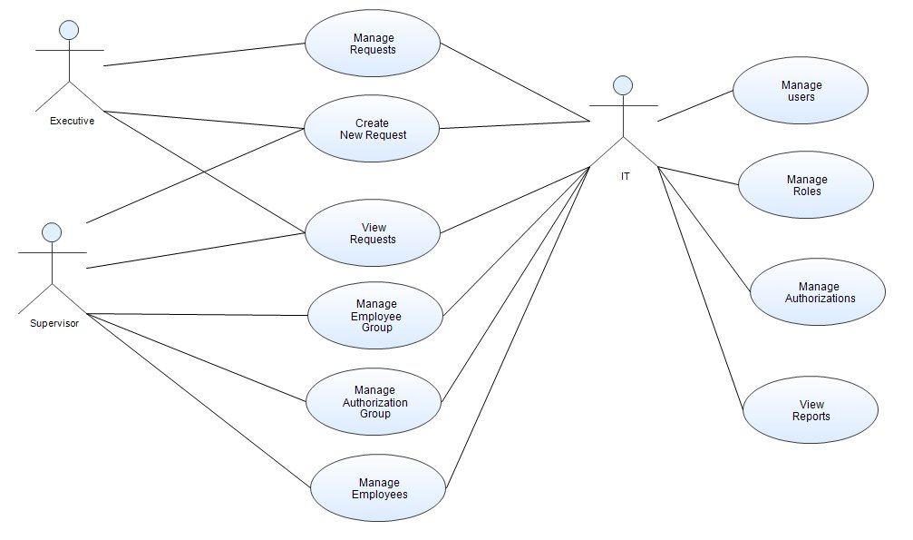

Actors on the Diagram
Executive | ACTR-103
IT | ACTR-102
Supervisor | ACTR-104

Use Cases on the Diagram
Create New Request | UC-105
Manage Authorization Group | UC-109
Manage Authorizations | UC-108
Manage Employee Group | UC-111
Manage Employees | UC-110
Manage Requests | UC-107
Manage Roles | UC-113
Manage users | UC-112
View Reports | UC-114
View Requests | UC-106

Use Cases
Create New Request
UC-105
Description (Goal in context)
Create New Request including System Access Request, System Removal Request and Employee Termination Request.
During a process, basic information, such as employee's full name, position, branch, member number, etc.., will be shown when an employee is selected. Also, all authorizations that the employee has will be listed.
Information of selected authorization is shown as well, such as authorization name, the owner and description.
In addition, comments is optional for user.
Moreover, review of request will be shown.
After all, an email notification will be sent to Executive.

Primary Actors

- Supervisor [ACTR-104]

Supporting Actors

- Executive [ACTR-103]

- IT [ACTR-102]

Pre conditions
1. In employee list, everyone should be current employee, which means, termination Date must be greater than current date.
2. In authorization list, every item should be active.
3. Selected employees and authorizations cannot be empty.

Main Flow-of-Events
1. Supervisor Select Employees
2. Supervisor Select Authorizations
3. Supervisor Review
4. Supervisor Submit
5. System Send Email Notification
6. System Show Result

Alternate Flows

1a. Show Basic Information <Click Any Item in Employee List>
1. Show employee's basic information

1b. Show Included Employees in Employee Group <DropdownList Selected Changed>
1. Show employee list in selected group

1c. Select Emploees
1. One by one in employee list to Selected Employee List
2. By existed group to Selected Employee List
3. If ( select employee in Selected Employee List ) then
3.1. show a duplication message
4. Else if ( select employee not in Selected Employee List ) then
4.1. add to Selected Employee List

1d. Unselect Employee
1. remove employee from Selected Employee list

2a. Show Information <Click Any Item In Authorization List>
1. Show information of selected authorization

2b. Show Included Authorization Group <DropdownList Selected Changed>
1. Show authorization list in selected group

2c. Select Authorizations
1. One by one in authorization list to Selected Authorization List
2. By existed group to Selected authorization List
3. If ( select authorization in Selected Authorization List ) then
3.1. show a duplication message
4. Else if ( select authorization not in Selected authorization List ) then
4.1. add to Selected Authorization List

2d. Unselect Authorization
1. remove authorization from Selected Authorization list

4a. Modify Reuqest <Click Edit Button>
1. Continue from step 1. of Main Flow-of-Events.

6a. Show Result Message
1. If ( result from Database and email contains "err" ) then
1.1. Use Case ends with Failure.
2. Else
2.1. Use Case ends with Success.

Post conditions
Success end condition
- Get a successful message and email is sent
Failure end condition
- get a failure message or email is not sent
Minimal Guarantee
- Showing exceptions to guide user

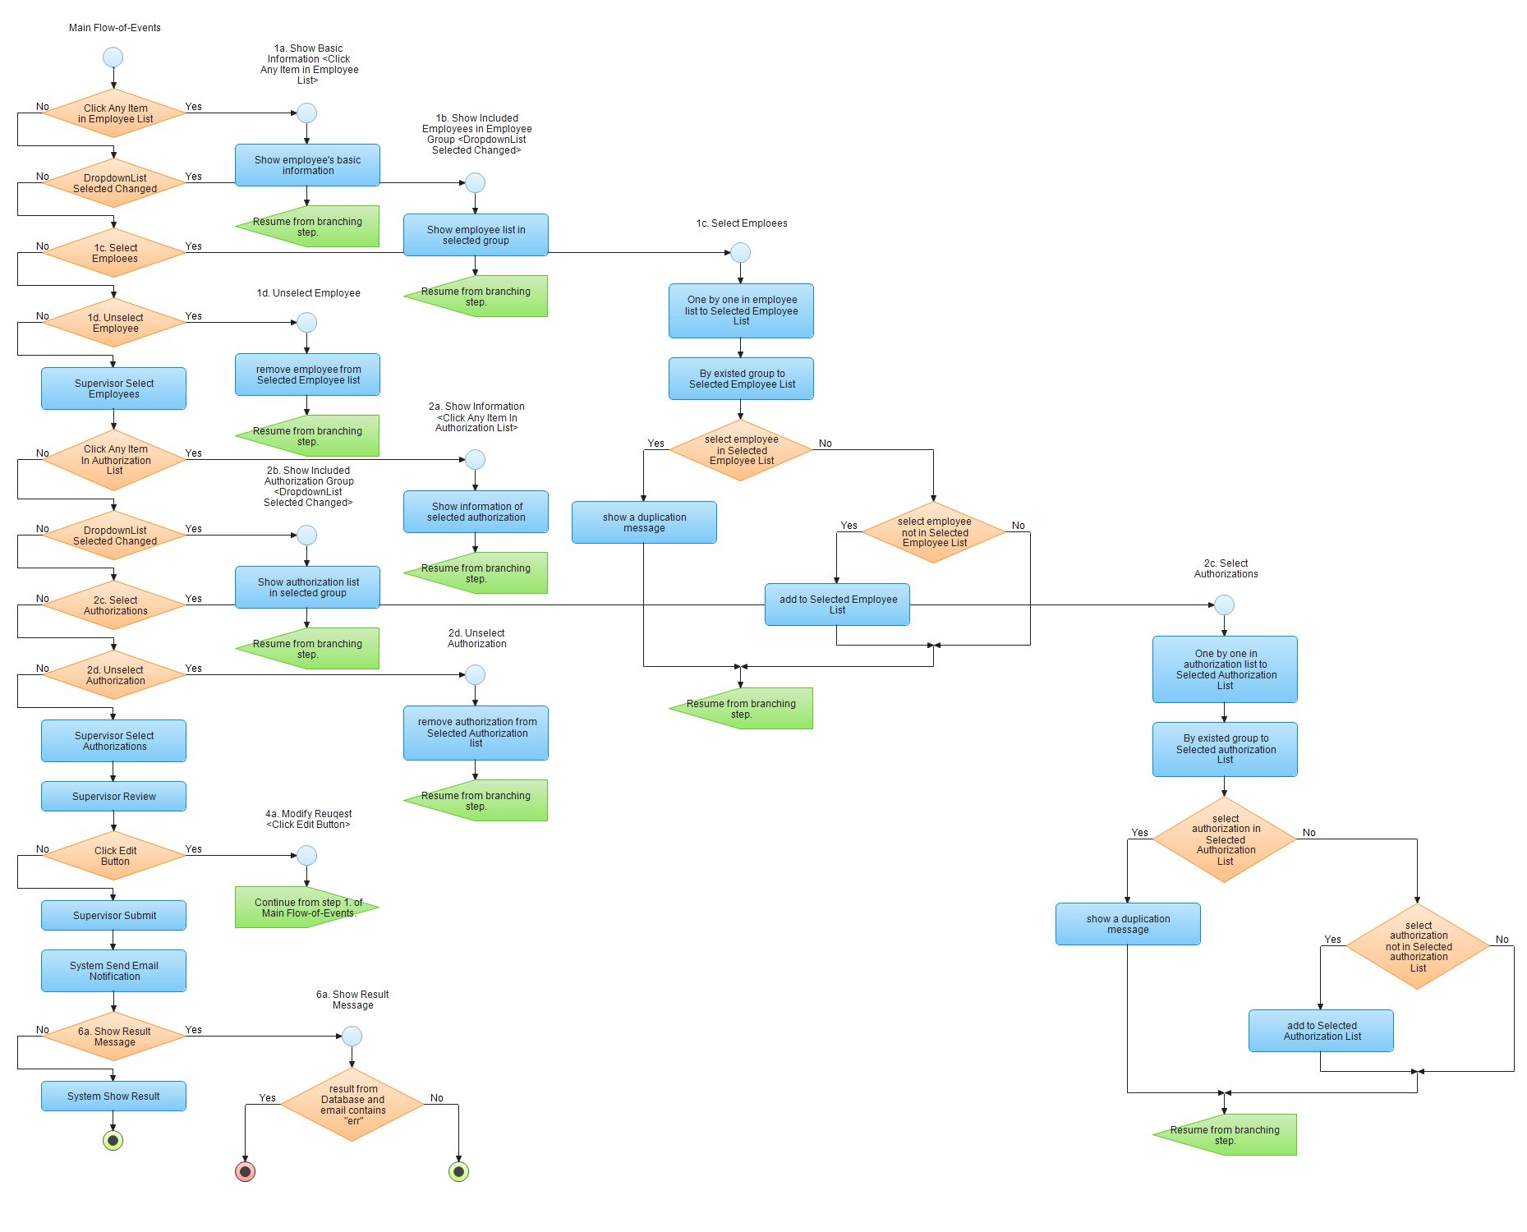

View Requests
UC-106

Primary Actors

- Executive [ACTR-103]

- IT [ACTR-102]

- Supervisor [ACTR-104]

Supporting Actors

Main Flow-of-Events
1. Supervisor Executive IT Show Requests

Alternate Flows

1a. Show My Requests <DropdownList Selected Changed>
1. Show user's requests only

1b. Show Pending Request <DropdownList Selected Changed>
1. Show user's pending request only

1c. Show Processed Requests <DropdownList Selected Changed>
1. Show user's processed requests only

Post conditions
Success end condition
-
Failure end condition
-
Minimal Guarantee
-

